**ASSIGNMENT 5 - Modeling Object Relationships**

Due Week 9

**Task 1 - Build Your Own Super Model**

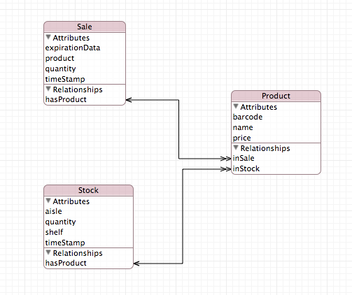

Firstly, to store the data in the App, we should design the entity-relationship-diagram. With the relationship between each entity, if a product detail is updated, when do not need update all transaction within the product. If can help to improve the effective the data model. In this business rules, employees are required to update the stocks and sales transactions. The product and its quantity must be record. Within some business rules, different product has the different promotion days. The system should record the product set to on sale or remove.

The App should have a scanner equipment to scan each product price. Once the product is scanned, the product’s name, category and price should display on the screen. The employee can enter the product quantity and action (on/off sale, stocks on shelf or remove from shelf). When employee chooses different action, the more detailed option should display. When employee confirms the quantity and transaction.

Finally, to test the following hypotheses, this data should post to database online. The mobile phone has the limit CPU and powers. It cannot analysis a large mount of data. The mobile device does not need a selling system to record sale transactions.

In the entity relationship diagram, there are 3 entity, they are Product, Sale and Stock. The products are record in this entity. The relationship between Sale and Stock entity to Product is one-to-many relationship, because there are many products in a sale or stock table. Apple suggests that reversed relationship should be used to make strong relationship. This data is usually read-only. The unique identify attributes is barcode. The unique barcode is an integer. It can help index the database to with better performance. The Sale and Stock entity records the transaction with product moved. To distinguish add and remove action by employee, the App will use the positive and negative quantity to represent the quantity increased and decease.

**Task 2 - Predicates & Sort Descriptors**

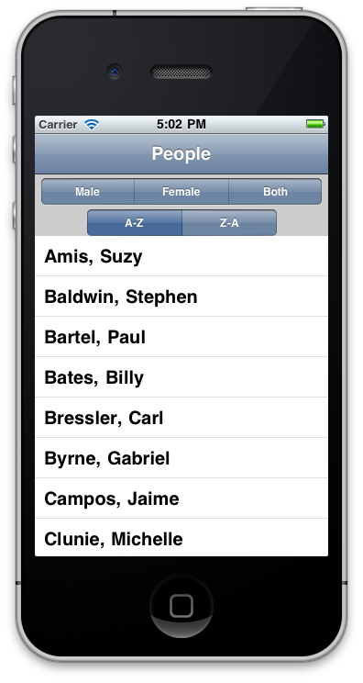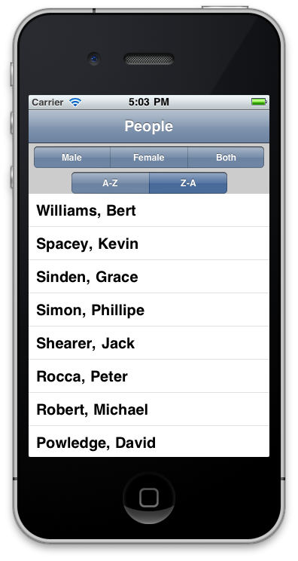

Sored Ascending and Descending

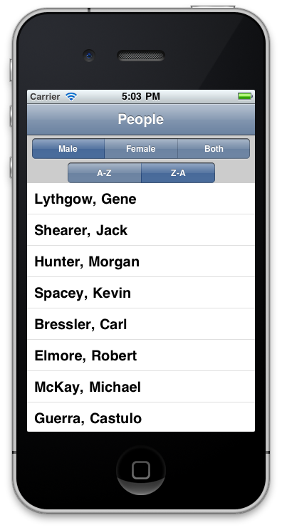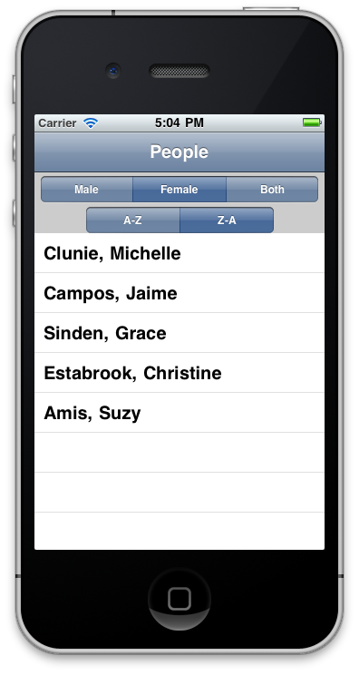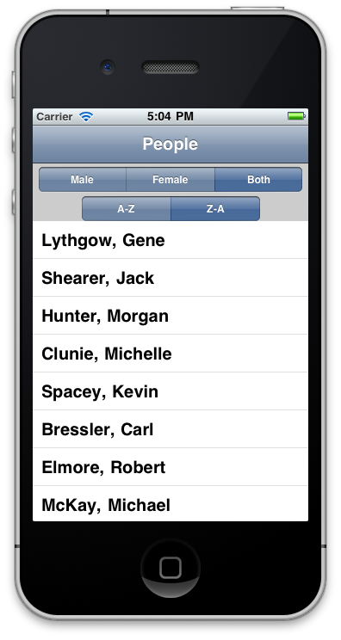

Filtered Male, Female and Both